1 Overview of SVKS
1.1 Introduction
The k_means algorithm is well known for its efficiency in clustering large data set, however, working only on numeric data limits the use of these k_means_type algorithm. The k_modes algorithm has removed the numeric-only limitation of the k_means algorithm which extends the k_means algorithm by using a simple matching dissimilarity measure for categorical objects, modes instead of means for clusters, and a frequency-base method to update modes in the clustering process to minimize the clustering cost function.
The limitation of k_modes algorithm is that each attribute of the object only has a single categorical value. In real application, some objects maybe have more than one value for an attributes. For instance, many people may have several job titles and more than one hobby or email. Such data representation is very widespread in questionnaire, banking, insurance, retails, and medical databases. The capacity to deal with the categorical data with set-valued attributes is undoubtedly important for clustering algorithm.
The package provides a complementary algorithm methodology to enrich clustering algorithm, especially clusters categorical data. To facilitate research efforts on this novel direction, we develop the open-source package called（）.
1.2 Architecture of SVKS

Data loader
.csv.file
.txt.file
Module 2
Single thread

Multi thread

Distributed Computation

Module 1
K-modes
Initial class center selection function
Fuzzy k-modes
SV-k-modes
Fuzzy SV-k-modes
Sub function
Sub function
Distance function
Find mode function
Distance function
Find mode function

The package architecture is based on a separation of two modules.
In the module 2, the package provides three operation modes to implement the clustering algorithm, single thread, multi thread, and distribute computation. Meanwhile, multi-thread operation is used to take advantage of multi-core machines to cluster categorical data. In the parallel operation, it is provided with multiple CPU to execute multiple threads at the same time which equivalently create a set of copies of functions running in parallel .Through the multi thread operation, it will improve the overall processing performance. In addition, by using distributed computing technology, the task will be decomposed into a number of small parts, and assigned to multiple computers for processing, which can save the overall computing time,and greatly improve the computational efficiency.
Based on the above operation mode, the module 1 includes k-modes algorithm ( Huang et al., 1998 ), fuzzy k-modes algorithm ( Huang et al., 1999 ), SV-k-modes algorithm, ( Cao et al., 2015), and fuzzy SV-k-modes algorithm ( Cao et al., 2015) to achieve the clustering for categorical data.
The implementation of the algorithms in module 1 depends on the sub functions, including the distance function, find mode function, and initial class center selection function.
These modules in the architecture are related to each other, and all codes follow the R standards. This guarantees that the package is simple, easy to implement, and easily extendable.
1.3 Core function overview
The core functions provided in the package are listed in Table 1.
Table 1 Core functions
R Function | Corresponding Algorithm
K_modes _S | K_modes algorithm(Single threaded)
K_modes _M | K_modes algorithm(Multi _threaded)
K_modes_D | K_modes algorithm(Distributed Computation)
F_K_modes _S | Fuzzy K_modes algorithm(Single threaded)
F_K_modes _M | Fuzzy K_modes algorithm(Multi _threaded)
F_K_modes_D | Fuzzy K_modes algorithm(Distributed Computation)
K_dis | Distance function of K_modes algorithm
K_center | Find mode function of K_modes algorithm
SV_K_modes _S | SV_K_modes algorithm(Single threaded)
SV_K_modes _M | SV_K_modes algorithm(Multi _threaded)
SV_K_modes_D | SV_K_modes algorithm(Distributed Computation)
F_SV_K_modes _S | Fuzzy SV_K_modes algorithm(Single threaded)
F_SV_K_modes _M | Fuzzy SV_K_modes algorithm(Multi _threaded)
F_SV_K_modes_D | Fuzzy SV_K_modes algorithm(Distributed Computation)
SV_K_dis | Distance function of SV_K_modes algorithm
SV_K_center | Find mode function of SV_K_modes algorithm
K_modes_k_initial_center | Initial cluster centers of k_modes
SV_K_modes_k_initial_center | Initial cluster centers of SV_k_modes

2 Setup in R
2.1 Getting and installing
To run the package, it is required that (1) Windows 7 operating system and above the version;(2)R 2.14.0, or above to be installed; (3)RStudio (3) The package should be loaded to the folder of current path, as shown in Figure 2.
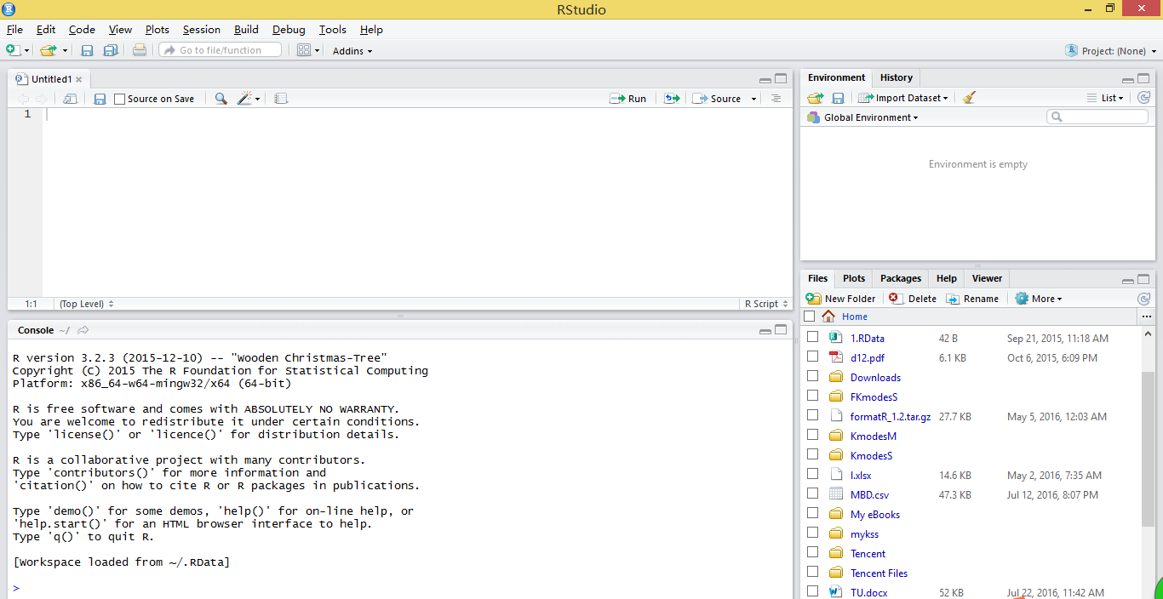
Figure 2 Loading the package
To use RStudio, you must install R in advance. Meanwhile, we can also use R to finish our work, as shown in Figure3. In this paper, we choose to use RStudio, which is a powerful and useful tool for R.
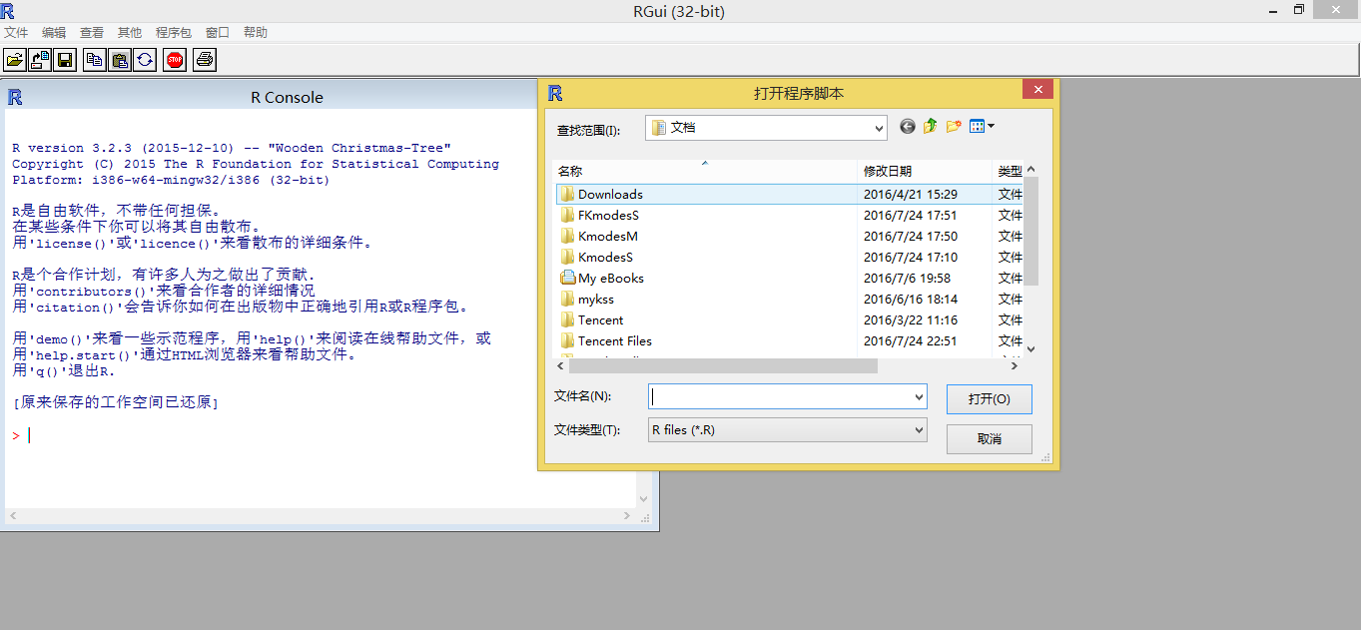
Figure 3 the Interface of R
2.2 Data format
It is required that a data set should be correctly imported to RStudio. Currently, R supports the csv file, txt file, and excel file.
An example in RStudio is given in Figure 4. The lines represent the number of instances, and the columns represent the number of attributes. “header=FALSE or TRUE” represents that whether the first line is used as the column name. If the first line is used as the column name, we will input “ header=True ”. If not, input “ header=FALSE ”.
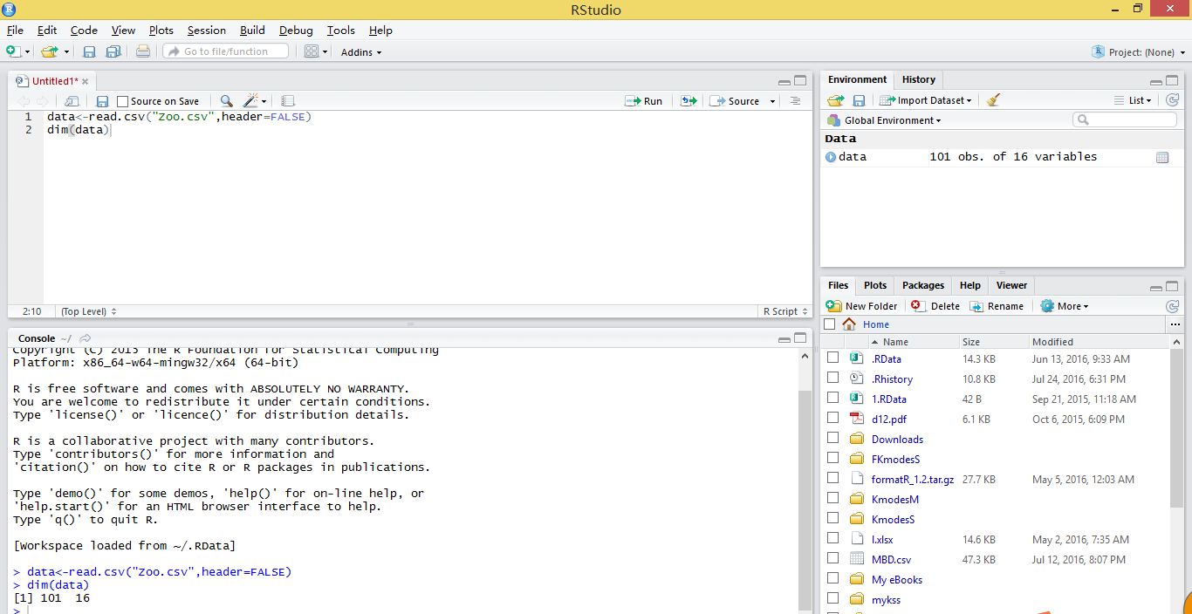
Figure 4 Example of Data format
This denotes that the data set contains 101 data instances, and the 16 columns represent the number of attributes. “header=FALSE ” represents that the first line is not used as the column name.

3 Core functions
3.1
3.1.1 K_modes _S
Description
Implement the K_Modes algorithm for single threaded.
Usage
Hard_K_Mode(data, k, InitialCenters)
return(iter, cid, time)
Arguments
Inputs | Data | Data set to be clustered
Inputs | K | Number of clusters
Inputs | InitialCenters | Initial cluster centers
Outputs | iter | Iteration number
Outputs | cid | Clustering result
Outputs | time | Computational cost
Details
The k_modes algorithm extends the k_means algorithm by using a simple matching dissimilarity measure for categorical objects, modes instead of means for clusters, and a frequency_base method to update modes in the clustering process to minimize the clustering cost function.
Reference
Z.Huang, ” Extensions to the k_means algorithm for clustering large data sets with categorical values,” Data Mining and Knowledge Discovery, vol.2, no. 3. Pp. 283 - 304, 1998
Example
Data<-read.csv(“Zoo.csv”,header=FALSE)
K<-7
InitialCenters<-NULL
library(KmodesS)
Hard_K_Mode(data, K, InitialCenters)
Results
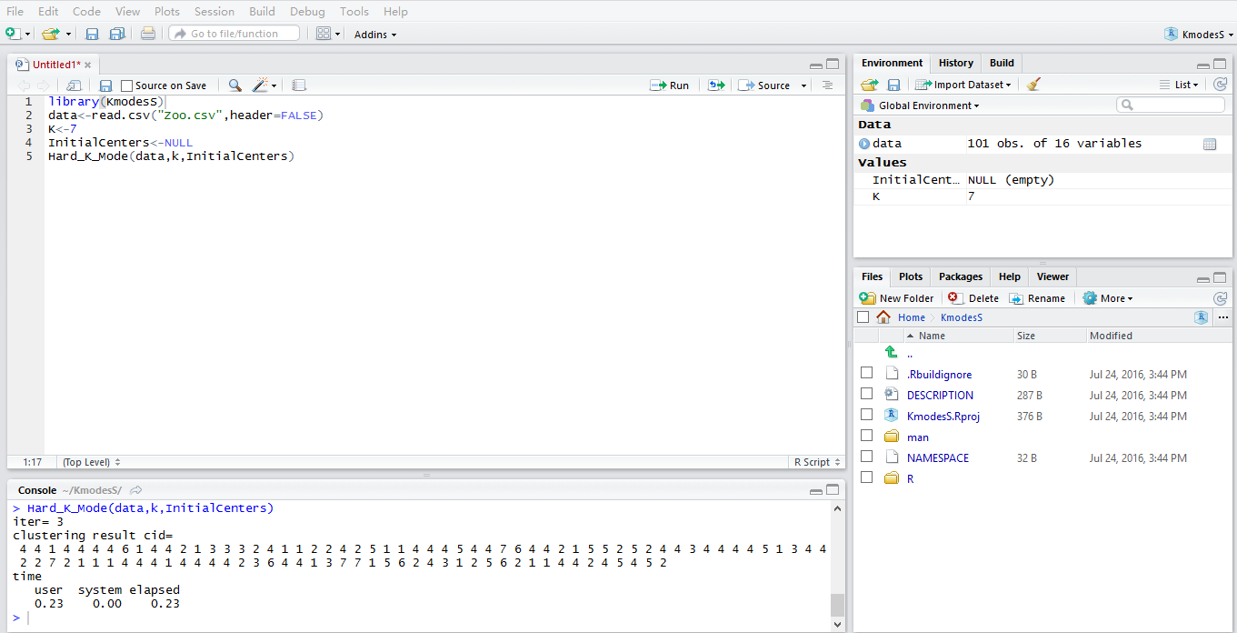
Figure 5 Example of the K_modes _S function
3.1.2K_modes _M
Description
Implement the K_Modes algorithm for multi thread operation.
Usage
Hard_K_Mode_M(data, k, InitialCenters)
return(iter, cid, time)
Arguments
Inputs | data | Data set to be clustered
Inputs | K | Number of clusters
Inputs | InitialCenters | Initial cluster centers
Outputs | iter | Iteration number
Outputs | cid | Clustering result
Outputs | time | Computational cost

Details
Multi thread operation is used to take advantage of multi-core machines and clusters of categorical data with reduce elapsed times. The operation o is provided with multiple CPU to execute multiple threads at the same time which equivalently create a set of copies of KmodesS package running in parallel .Through the multi thread operation, it will improve the overall processing performance.
Reference
Z.Huang, ” Extensions to the k_means algorithm for clustering large data sets with categorical values,” Data Mining and Knowledge Discovery, vol.2, no. 3. Pp. 283 - 304, 1998
Example
library(KmodesM)
data<-read.csv(“Zoo.csv”,header=FALSE)
K<-7
InitialCenters<-NULL
Hard_K_Mode_M(data, K, InitialCenters)
Results
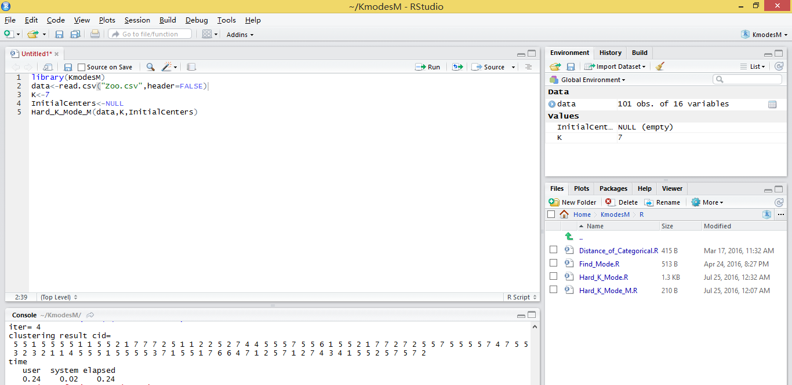
Figure 6 Example of the K_modes _M function
3.1.3 K_modes_D
Description
Implement the K_Modes algorithm for distributed computing.
Usage
Hard_K_Mode_D(data, k, InitialCenters)
return(iter, cid, time)
Arguments
Inputs | Data | Data set to be clustered
Inputs | K | Number of clusters
Inputs | InitialCenters | Initial cluster centers
Outputs | iter | Iteration number
Outputs | cid | Clustering result
Outputs | time | Computational cost

Reference
Z.Huang, ” Extensions to the k_means algorithm for clustering large data sets with categorical values,”,Data Mining Knowledge Discovery, vol.2,no.3,Sept.1998
Example
library(KmodesD)
data<-read.csv(“Zoo.csv”,header=FALSE)
K<-7
InitialCenters<-NULL
Hard_K_Mode_D_mr(to.dfs(data), K, InitialCenters)
Results
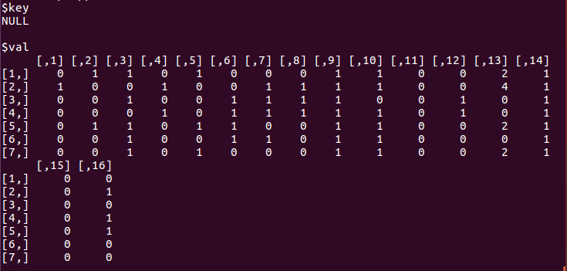

3.1.4 F_K_modes _S
Description
Implement the Fuzzy_ K_Modes algorithm for single threaded.
Usage
Fuzzy_K_Mode(data, K, InitialCenters,a)
return(iter, cid, time)
Arguments
Inputs | data | Data set to be clustered
Inputs | K | Number of clusters
Inputs | InitialCenters | Initial cluster centers
Inputs | a | index
Outputs | cid | Clustering result
Outputs | time | Computational cost
Outputs | iter | Iteration number

Details
The fuzzy k_modes algorithm is achieved by the development of a new procedure to generate the fuzzy partition matrix from categorical data within the framework of the fuzzy k_means algorithm.The main result of the algorithm is to find the fuzzy cluster modes when the simple matching dissimilarity measure is used for categorical objects.
Reference
Z.Huang and Michael K.Ng,”A fuzzy k_modes algorithm for clustering categorical data,” Fuzzy System, IEEE Transaction on, vol. 7. No. 4 pp. 446-452.1999
Example
data<-read.csv(“Zoo.csv”,header=FALSE)
K<-7
InitialCenters<-NULL
a<-1.1
library(FKmodesS)
Fuzzy_K_Mode(data,K,InitialCenters,a)
Results
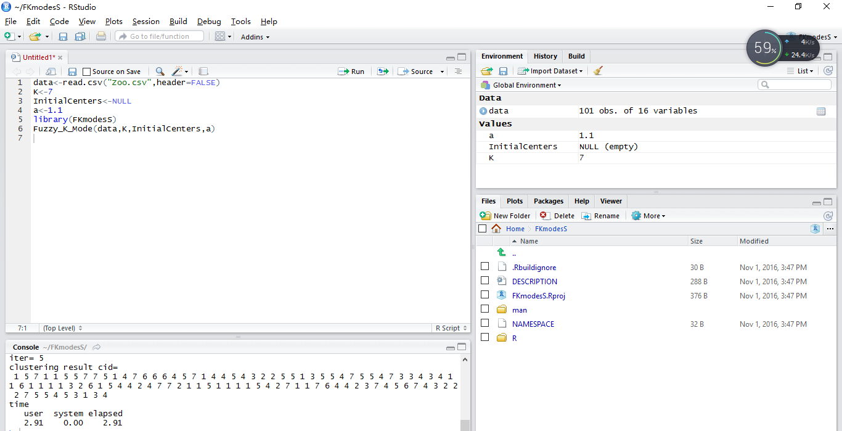

3.1.5 F_K_modes _M
Description
Implement the Fuzzy_ K_Modes algorithm for multi thread operation.
Usage
Fuzzy_K_Mode_M(data,K,InitialCenters,a)
return(iter, cid, time)
Arguments
Inputs | data | Data set to be clustered
Inputs | K | Number of clusters
Inputs | InitialCenters | Initial cluster centers
Inputs | a | index
Outputs | cid | Clustering result
Outputs | time | Computational cost
Outputs | iter | Iteration number

Details
Please refer to the details of the F_K_modes _S mentioned above.
Reference
Z.Huang and Michael K.Ng,”A fuzzy k_modes algorithm for clustering categorical data,” Fuzzy System, IEEE Transaction on, vol. 7. No. 4 pp. 446-452.1999
Example
data<-read.csv(“Zoo.csv”,header=FALSE)
K<-7
InitialCenters<-NULL
a<-1.1
library(FKmodesM)
Fuzzy_K_Mode_M(data,K,InitialCenters,a)
Results
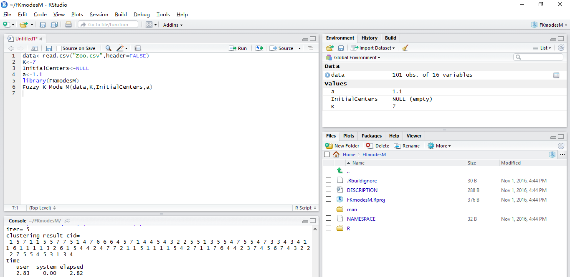

3.1.6 F_K_modes_D
Description
Implement the Fuzzy_ K_Modes algorithm for distributed computing.
Usage
Fuzzy_K_Mode_D(data,K,InitialCenters,a)
return(iter, cid, time)
Arguments
Inputs | data | Data set to be clustered
Inputs | K | Number of clusters
Inputs | InitialCenters | Initial cluster centers
Inputs | a | index
Outputs | nj | Clustering result

Reference
Z.Huang and Michael K.Ng,”A fuzzy k_modes algorithm for clustering categorical data,” Fuzzy System, IEEE Transaction on, vol. 7. No. 4 pp. 446-452.1999
Example
data<-read.csv(“Zoo.csv”,header=FALSE)
K<-7
InitialCenters<-NULL
a<-1.1
library(FKmodesD)
Fuzzy_K_Mode_D(data,K,InitialCenters,a)
Results
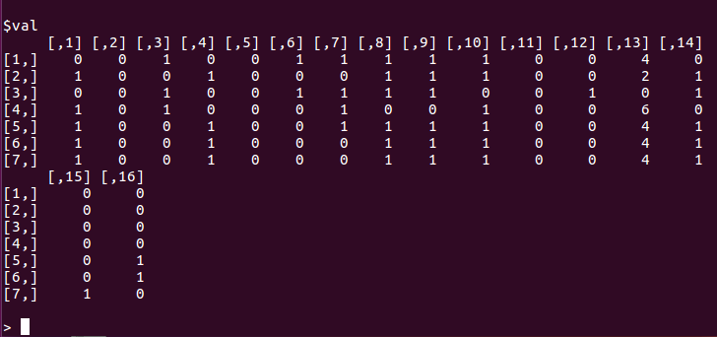

3.1.7 K_dis
Description
Calculate the distance between each object to the class center.
Usage
Distance_of_Categorical(Data1,Data2)
Return(distance)
Arguments
Inputs | Data1 | A vector in data matrix
Inputs | Data2 | A vector in data matrix
Output | distance | The distance between Data1 and Data2

Details
A simple 0 - 1 matching method is used to calculate the distance between the two attributes of different objects in the same classification.
Example
Data<-read.csv(“Zoo.csv”,header=FALSE)
Distance_of_Categorical(Data[1:10,],Data2[10:20,])
Results
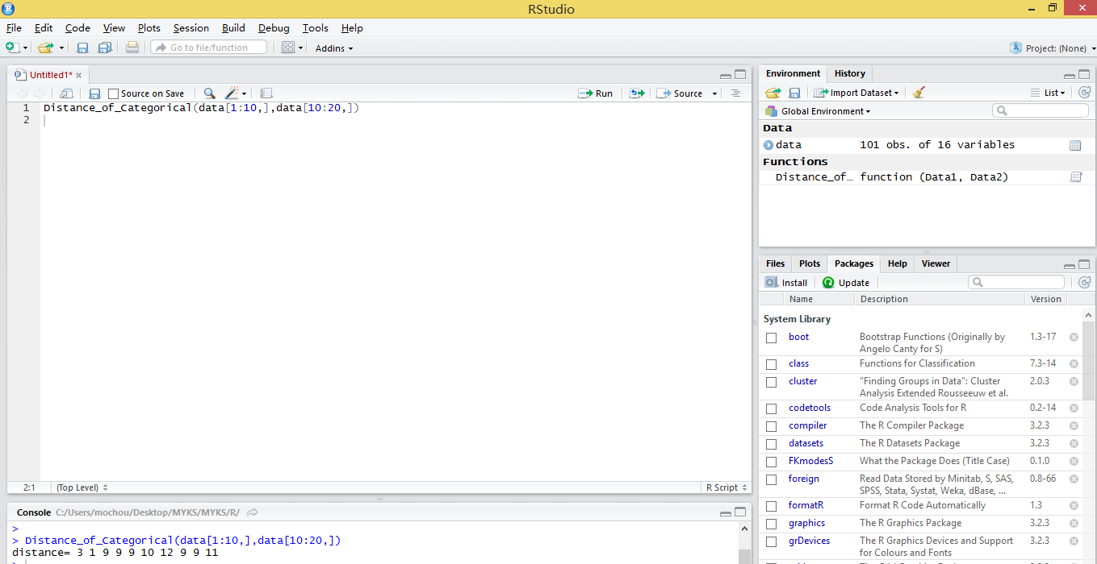

3.1.8 K_center
Description
Calculate the cluster centers for each class.
Usage
Find_Mode(Data)
return(NNew_Mode)
Arguments
Input | Data | A vector in data matrix
Output | NNew_Mode | The cluster centers for Data

Details
Calculate the maximum number of frequencies in each attribute as the center of each class.
Example
Data<-read.csv(“Zoo.csv”,header=FALSE)
Find_Mode(Data[1:30,])
Results
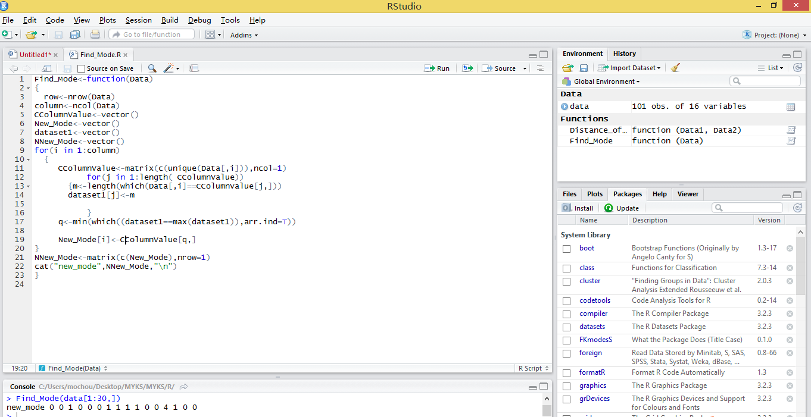

3.1.9 SV_K_modes _S
Description
Implement the SV_K_modes algorithm for single threaded.
Usage
New_ratio_k_multi_modes(Data, K, InitialCenters)
return(iter, cid, time)
Arguments
Inputs | Data | Data set to be clustered
Inputs | K | Number of clusters
Inputs | InitialCenters | Initial cluster centers
Outputs | Time | Computational cost

Details
The SV-k-modes clustering algorithm is designed to cluster the objects with set-valued attributes. The algorithm can partition data with mixed single-valued and set-valued attributes and the k-modes algorithm is its special case.
Reference
Fuyuan Cao, Joshua Zhexue Huang, Jiye Liang, Xingwang Zhao and Yinfeng Meng. “SV-k-modes: an Algorithm for Clustering Categorical Data with Set-valued Attributes,” Neural Networks and Learning System. IEEE Transaction, vol.13.No.9,April 2015
Example
library(SVKS)
Data<-read.csv(“MBD.csv”,header=FALSE)
K<-10
InitialCenters<-null
New_ratio_k_multi_modes(Data, K, InitialCenters)
Results
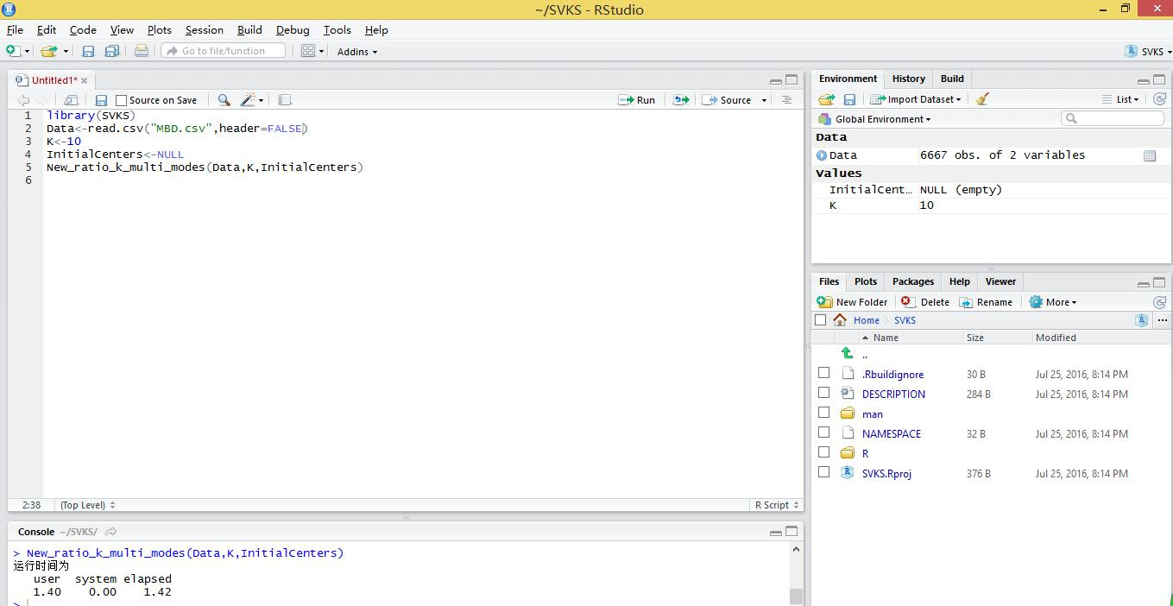

3.2.0 SV_K_modes _M
Description
Implement the SV_K_modes algorithm for multi_threaded.
Usage
New_ratio_k_multi_modes_M(Data, K, InitialCenters)
return(iter, cid, time)
Arguments
Inputs | Data | Data set to be clustered
Inputs | K | Number of clusters
Inputs | InitialCenters | Initial cluster centers
Outputs | Time | Computational cost
Details
Please refer to the description of the detail of the
Reference
Fuyuan Cao, Joshua Zhexue Huang, Jiye Liang, Xingwang Zhao and Yinfeng Meng. “SV-k-modes: an Algorithm for Clustering Categorical Data with Set-valued Attributes,” Neural Networks and Learning System. IEEE Transaction, vol.13.No.9,April 2015
Example
library(SVKM)
Data<-read.csv(“MBD.csv”,header=FALSE)
K<-10
InitialCenters<-NULL
New_ratio_k_multi_modes(Data, K, InitialCenters)
Results
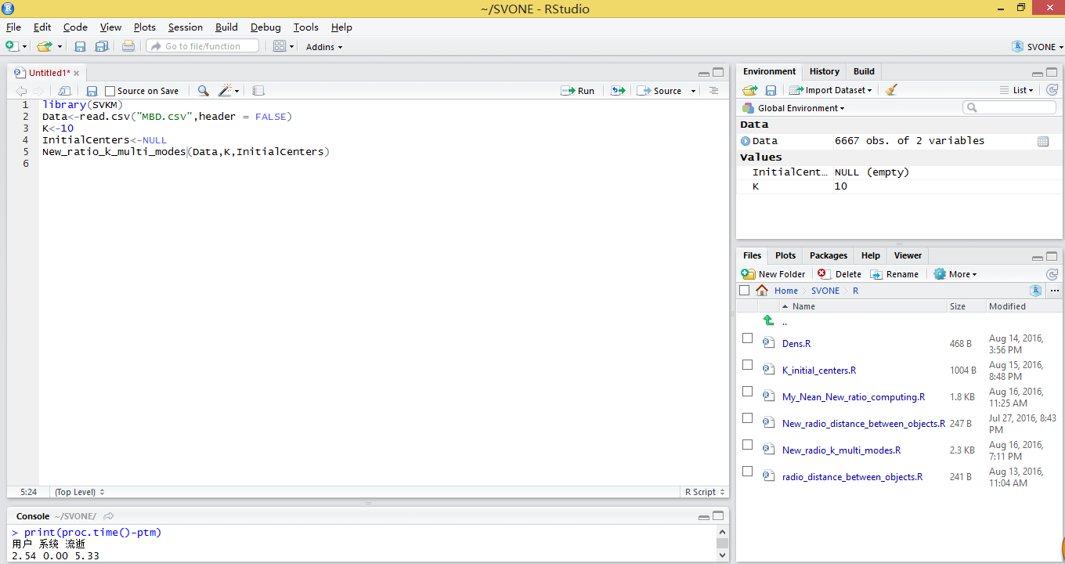

3.2.1 SV_K_modes_D
Description
Implement the SV_K_modes algorithm for distribute computation.
Usage
New_ratio_k_multi_modes_D(Data, K, InitialCenters)
return(iter, cid, time)
Arguments
Inputs | Data | Data set to be clustered
Inputs | K | Number of clusters
Inputs | InitialCenters | Initial cluster centers
Outputs | nj | Clustering result

Reference
Fuyuan Cao, Joshua Zhexue Huang, Jiye Liang, Xingwang Zhao and Yinfeng Meng. “SV-k-modes: an Algorithm for Clustering Categorical Data with Set-valued Attributes,” Neural Networks and Learning System. IEEE Transaction, vol.13.No.9,April 2015
Example
library(SVKD)
Data<-read.csv(“MBD.csv”,header=FALSE)
K<-10
InitialCenters<-null
New_ratio_k_multi_modes(Data, K, InitialCenters)
Results
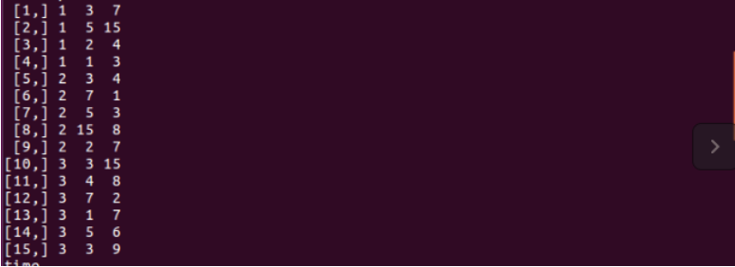

3.2.2 F_SV_K_modes _S
Description
Implement the fuzzy SV_K_modes algorithm for single threaded.
Usage
Fuzzy_ratio_k_multi_modes(Data,K,InitialCenters,a)
return(iter, cid, time)
Arguments
Inputs | Data | Data set to be clustered
Inputs | K | Number of clusters
Inputs | InitialCenters | Initial cluster centers
Outputs | Time | Computational cost

Reference
Fuyuan Cao, Joshua Zhexue Huang, Xingwang Zhao and Jiye Liang, A Fuzzy SV-k-modes Algorithm for Clustering Categorical Data with Set-valued Attributes
Example
library(FSVKS)
Data<-read.csv(“MBD.csv”,header=FALSE)
K<-10
InitialCenters<-null
a<-1.1
Fuzzy_ratio_k_multi_modes(Data,K,InitialCenters,a)
Results
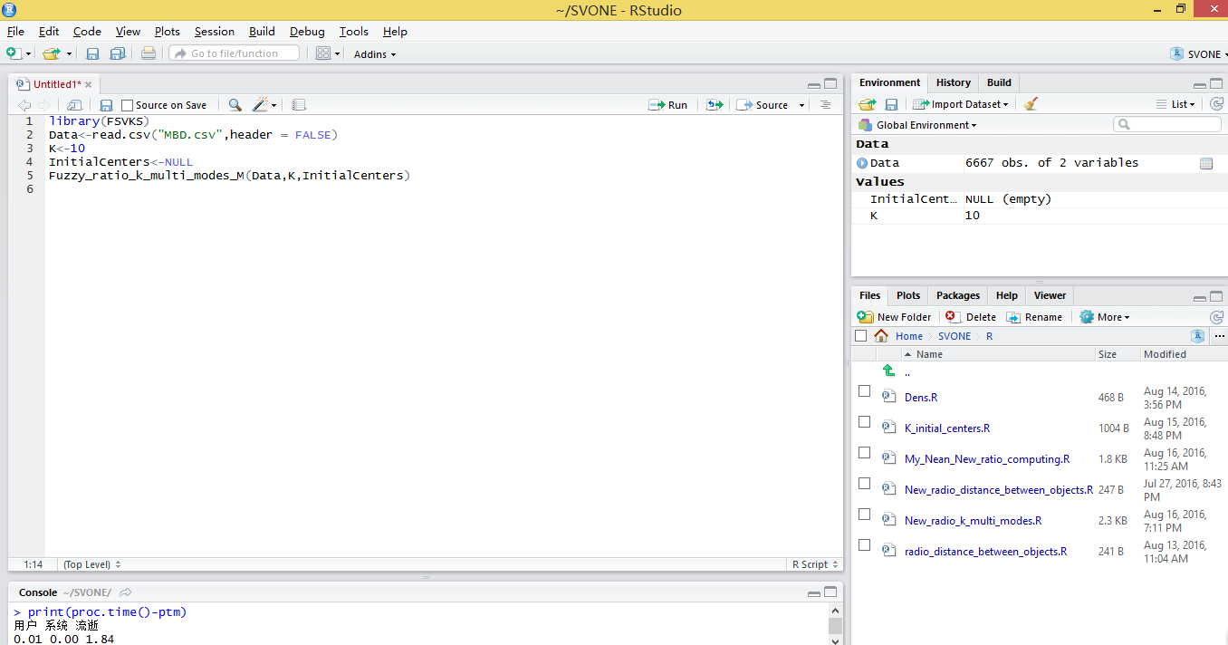

3.2.3 F_SV_K_modes _M
Description
Implement the fuzzy SV_K_modes algorithm for multi_threaded.
Usage
Fuzzy_ratio_k_multi_modes_M(Data,K,InitialCenters)
return(iter, cid, time)
Arguments
Inputs | Data | Data set to be clustered
Inputs | K | Number of clusters
Inputs | InitialCenters | Initial cluster centers
Outputs | Time | Computational cost

Reference
Fuyuan Cao, Joshua Zhexue Huang, Xingwang Zhao and Jiye Liang, A Fuzzy SV-k-modes Algorithm for Clustering Categorical Data with Set-valued Attributes
Example
library(FSVKM)
Data<-read.csv(“MBD.csv”,header=FALSE)
K<-10
InitialCenters<-null
Fuzzy_ratio_k_multi_modes_M(Data,K,InitialCenters)
Results
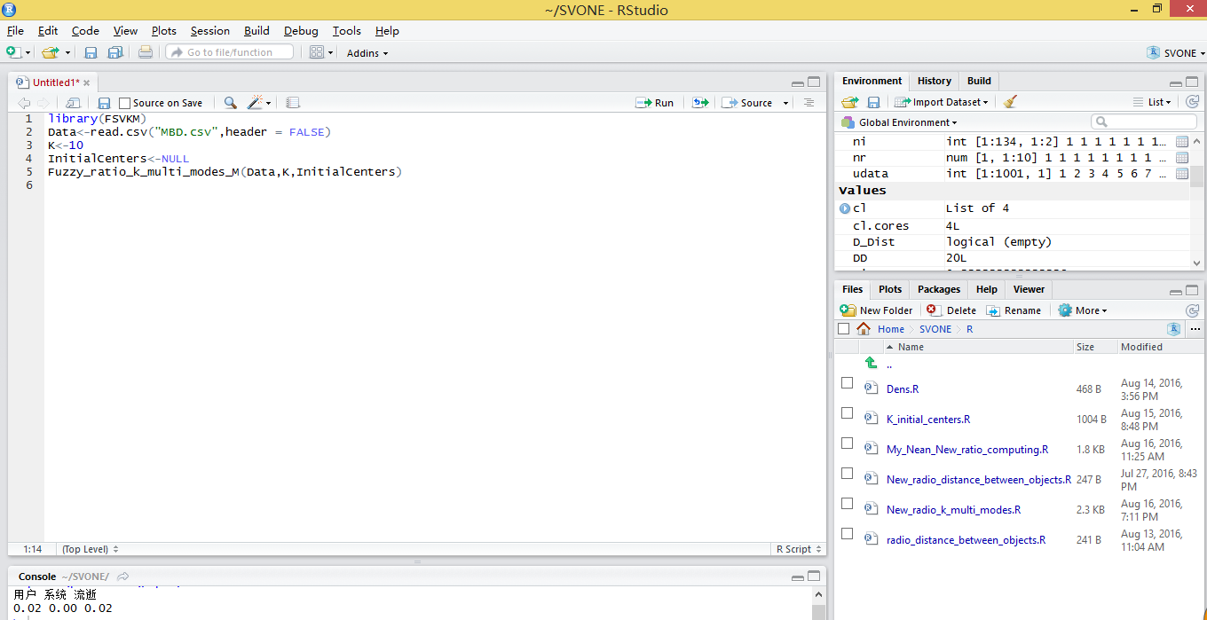

3.2.4 F_SV_K_modes_D
Description
Implement the fuzzy SV_K_modes algorithm for distribute computation.
Usage
Fuzzy_ratio_k_multi_modes_D(Data,K,InitialCenters)
return(iter, cid, time)
Arguments
Inputs | Data | Data set to be clustered
Inputs | K | Number of clusters
Inputs | InitialCenters | Initial cluster centers
Outputs | nj | Clustering result

Reference
Fuyuan Cao, Joshua Zhexue Huang, Jiye Liang, Xingwang Zhao and Yinfeng Meng,SV_k_modes: an Algorithm for clustering Categorical Data with Set_Valued Attributes, IEEE Transactions on meural networks and Learning system. Vol. 13. NO. 9. April. 2015
Example
library(FSVKD)
Data<-read.csv(“MBD.csv”,header=FALSE)
K<-10
InitialCenters<-null
Fuzzy_ratio_k_multi_modes_D(Data,K,InitialCenters)
Results
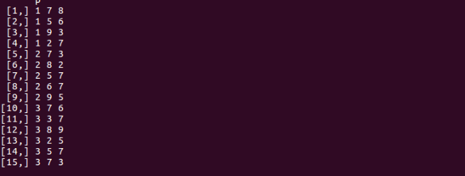

3.2.5 SV_K_dis
Description
The distance function of SV_K_modes algorithm.
Usage
New_ratio_distance_between_objects(DData1,DData2)
return(distance)
Arguments
Inputs | DData1 | A vector in data matrix
Inputs | DData2 | A vector in data matrix
Output | distance | The distance between Data1 and Data2
Details
Calculate the distance between each object to the center of each class.
Reference
Fuyuan Cao, Joshua Zhexue Huang, Jiye Liang, Xingwang Zhao and Yinfeng Meng. “SV-k-modes: an Algorithm for Clustering Categorical Data with Set-valued Attributes,” Neural Networks and Learning System. IEEE Transaction, vol.13.No.9,April 2015
Example
DData1<-c(1,3,5,6,8,9,2)
DData2<-c(2,4,5,7,8,1,9)
New_ratio_distance_between_objects(DData1,DData2)
Results
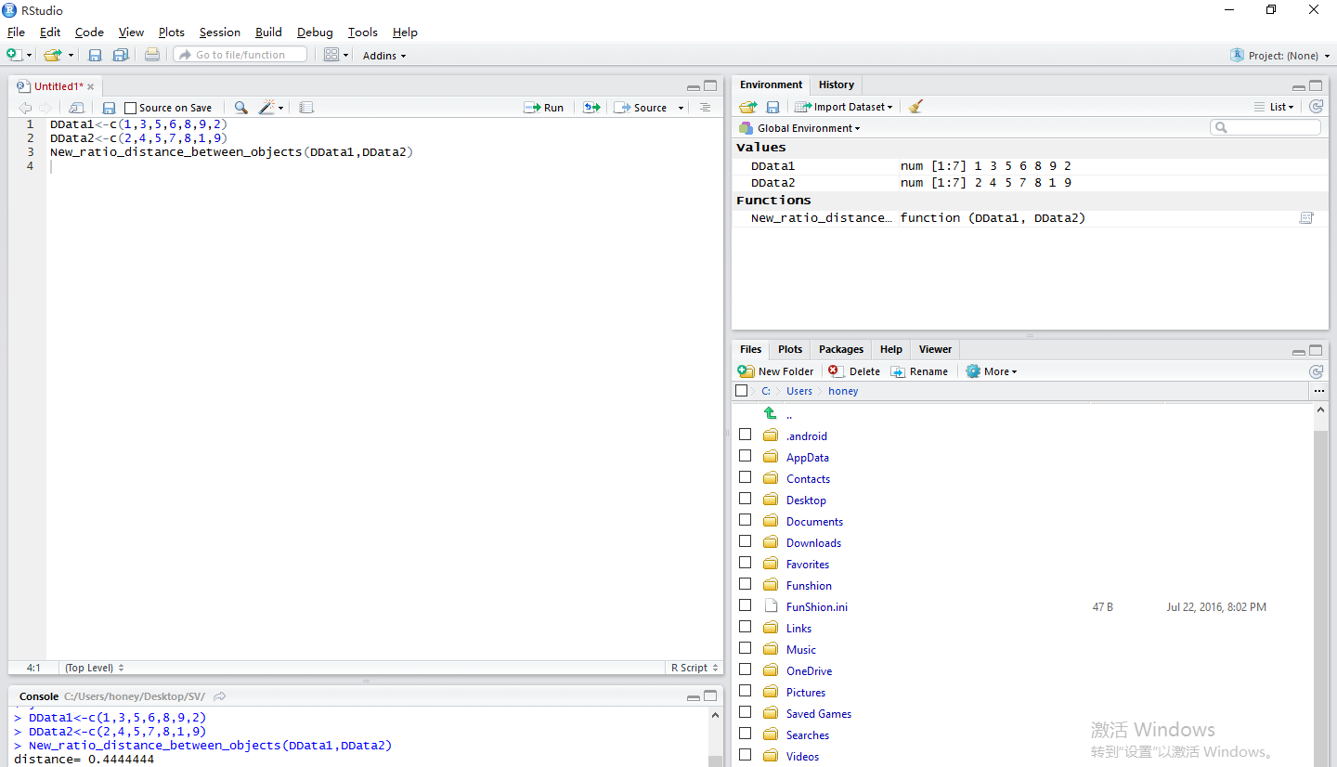

3.2.6 SV_K_center
Description
The find mode function of SV-K-modes algorithm.
Usage
My_Nean_New_ratio_computing_modes(data)
return(Mode)
Arguments
Input | data | A vector in data matrix
Output | Mode | The cluster centers for data
Details

Reference
Fuyuan Cao, Joshua Zhexue Huang, Jiye Liang, Xingwang Zhao and Yinfeng Meng,SV_k_modes: an Algorithm for clustering Categorical Data with Set_Valued Attributes, IEEE Transactions on meural networks and Learning system. Vol. 13. NO. 9. April. 2015
Example
Data<-read.csv(“MBD1.csv”,header=FALSE)
My_Nean_New_ratio_computing_modes(data)
Results
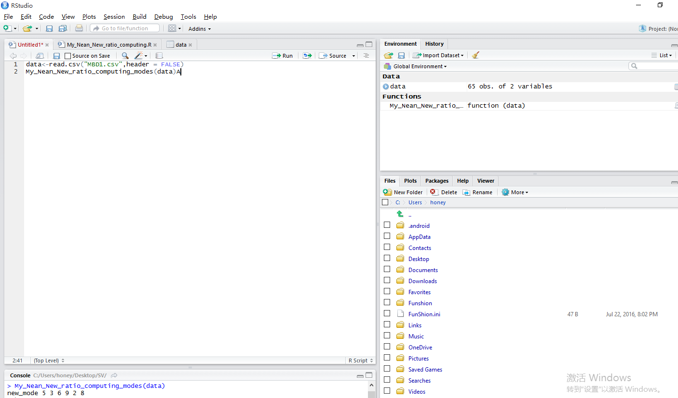

3.2.7 K_modes_k_initial_center
Description
The initialization clustering algorithm to select the initial cluster centers for the k_modes algorithm.
Usage
k_initial_center<-function(data,K)
return(DDist)
Arguments
Input | data | A vector in data matrix
Input | K | Number of clusters
Output | DDist | Initial cluster centers

Details
The initialization clustering algorithm for categorical data is given to choose first class center by calculating the average density of the objects. If selecting more initial centers, it needs to consider the density of an object and the distance between the object and the selected initial cluster centers simultaneously.
Example
Data<-read.csv(“Zoo.csv”,header=FALSE)
K<-7
Result
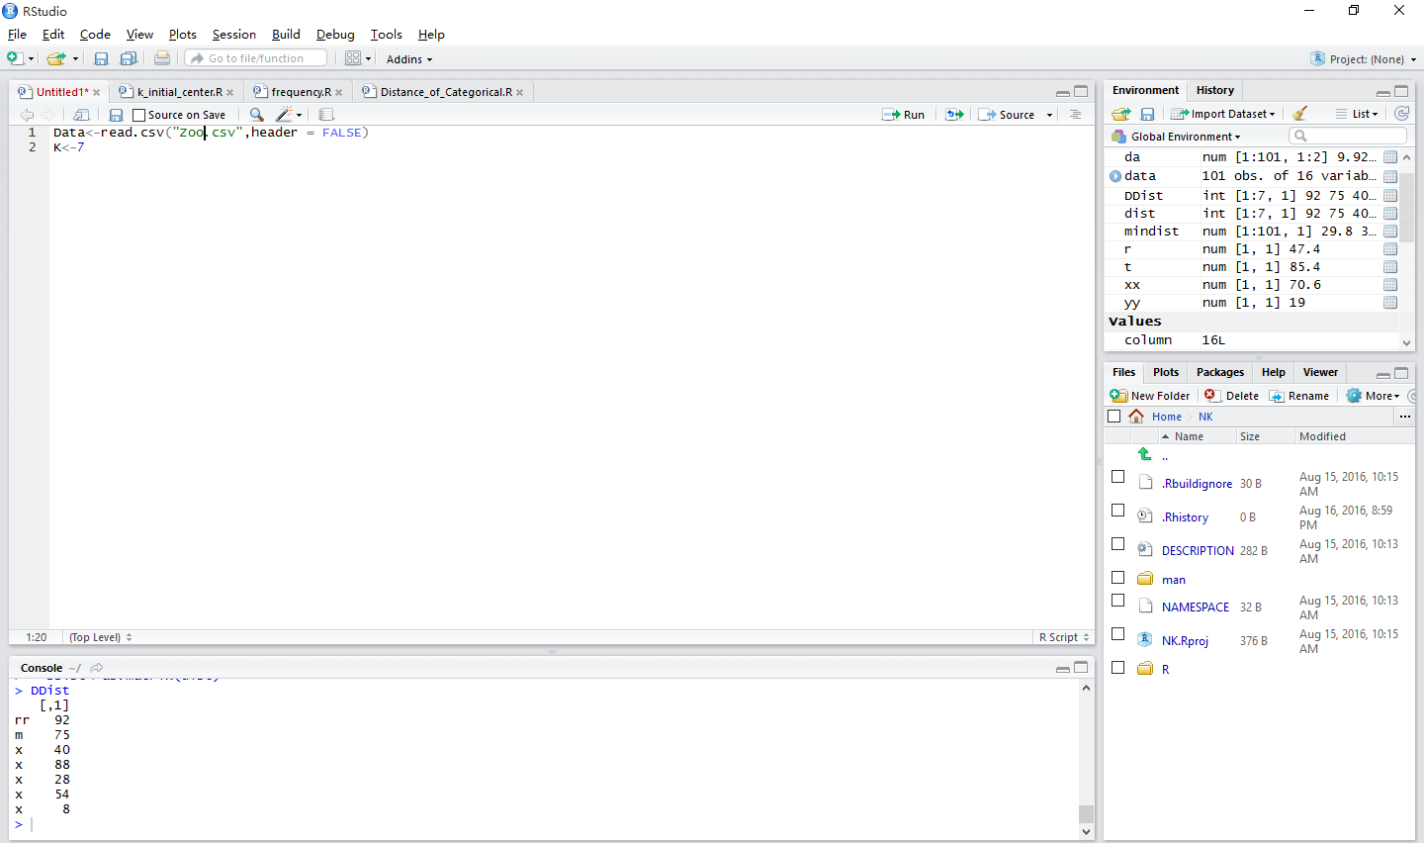

3.2.8 SV_K_modes_k_initial_center
Description
The initialization algorithm to select the initial cluster centers for the SV_k_modes algorithm.
Usage
K_initial_centers<-function(Data,K)
Return(dist)
Arguments
Input | Data | A vector in data matrix
Input | K | Number of clusters
Output | dist | Initial cluster centers

Details
The initialization algorithm is to select the initial cluster centers for the SV_k_modes algorithm by extending the initialization method. If selecting more initial centers, it needs to consider the density of an object and the distance between the object and the selected initial cluster centers simultaneously.
Reference
Fuyuan Cao, Joshua Zhexue Huang, Jiye Liang, Xingwang Zhao and Yinfeng Meng,SV_k_modes: an Algorithm for clustering Categorical Data with Set_Valued Attributes, IEEE Transactions on meural networks and Learning system. Vol. 13. NO. 9. April. 2015
Example
Data<-read.csv(“MBD2.csv”, header=FALSE)
K<-3
Result
